

Lab tasks 12 & 13
  - AI
  - (Artificial Intelligence)
Instructor: sir imran

Student Name: |  | Syeda Aima Abbas
Registration No: |  | FA24-BSE-010
Department: |  | Software Engineering
Submission Date: |  | ^{6th} December 2025

  - COMSATS University Islamabad
Lab 12

Prolog of Lab Task 1
parent(ali, ahmed).
parent(ali, fatima).
parent(ahmed, sara).
parent(fatima, zain).

% Gender facts
male(ali).
male(ahmed).
female(fatima).
female(sara).
male(zain).

% Rules (knowledge derived using modus ponens)

% Rule 1: If X is parent of Y and X is male then X is father of Y
father(X, Y) :-
parent(X, Y),
male(X).

% Rule 2: If X is parent of Y and X is female then X is mother of Y
mother(X, Y) :-
parent(X, Y),
female(X).

% Rule 3: If X is parent of Y and Y is parent of Z then X is grandparent of Z
grandparent(X, Z) :-
parent(X, Y),
parent(Y, Z).

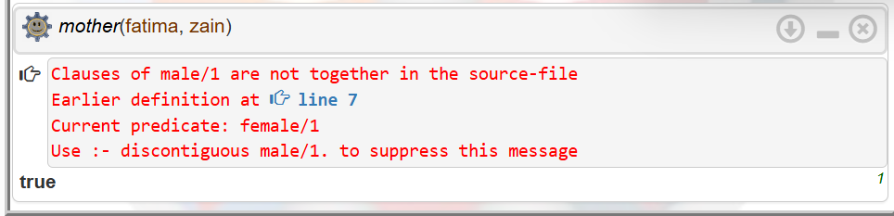

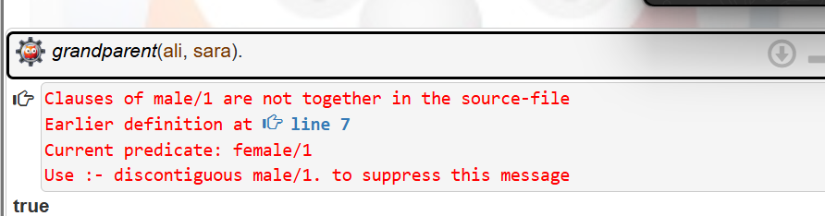
Lab 13
Lab Task 1
% Parent relationships
parent(ali, ahmed).
parent(ali, sana).
parent(ahmed, bilal).
parent(sana, noor).

% Brother relationships
brother(ahmed, sana).
brother(sana, ahmed).

% Rule using modus ponens
% If X is brother of Y and Y is parent of Z then X is uncle of Z
uncle(X, Z) :-
brother(X, Y),
parent(Y, Z).

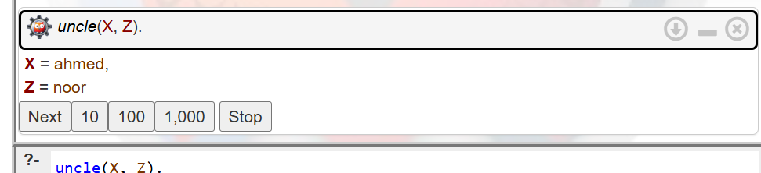
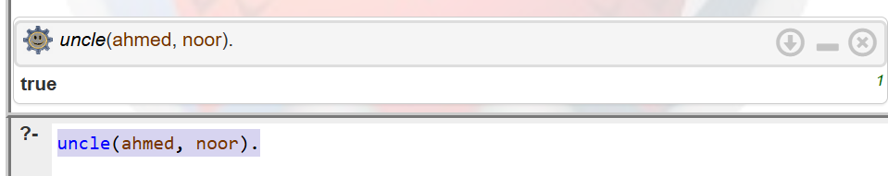
Lab Task 2
% Parent relationships
parent(ali, ahmed).
parent(ali, sana).
parent(ahmed, bilal).
parent(sana, noor).

% Brother relationships
brother(ahmed, sana).
brother(sana, ahmed).

% Rule using modus ponens
% If X is brother of Y and Y is parent of Z then X is uncle of Z
uncle(X, Z) :-
brother(X, Y),
parent(Y, Z).

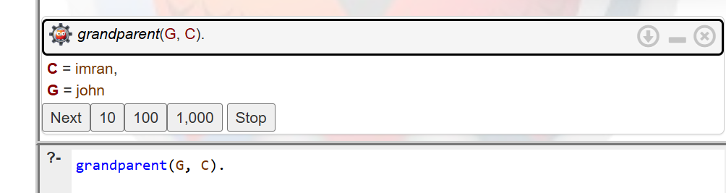
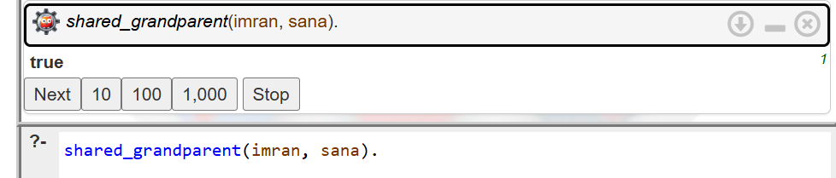
Lab Task 3
% Parent relationships
parent(ali, ahmed).
parent(ali, sana).
parent(ahmed, bilal).
parent(sana, noor).

% Brother relationships
brother(ahmed, sana).
brother(sana, ahmed).

% Rule using modus ponens
% If X is brother of Y and Y is parent of Z then X is uncle of Z
uncle(X, Z) :-
brother(X, Y),
parent(Y, Z).

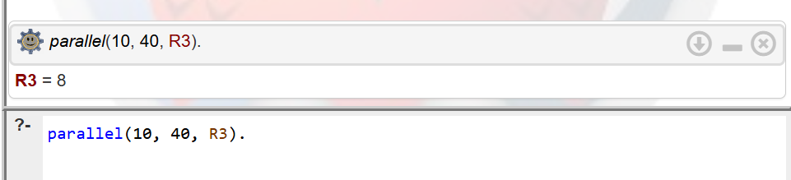
Lab Task 4
% Direct enclosure facts
encloses(b1, b2).
encloses(b1, b5).
encloses(b2, b3).
encloses(b2, b4).
encloses(b5, b6).
encloses(b6, b7).

% Rule: Transitive enclosure
% If X encloses Y and Y encloses Z then X encloses Z
encloses(X, Z) :-
encloses(X, Y),
encloses(Y, Z).

